**Thankful Thursday:** Thank our postal workers with an All Star sports card

Let us take the time to thank all of the Postal Workers at the US Post office in San Clemente for all of their hard work and bravery in these uncertain time.

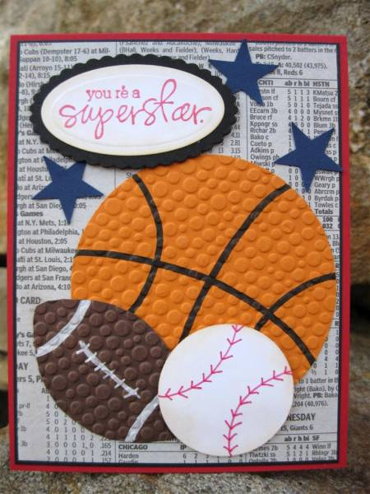

**Materials:**

-White Paper (1 piece), the printed PDF with the sports items and stars to cut out, crayons or markers Scissors, Glue

**Instructions:**

1. Fold your piece of white paper in half.
2. Color each of the sports balls and stars.
3. Cut each of the above items out.
4. Cut out the “You’re an All Star” portion.
5. See the above example and glue each item on as you want.
6. Open up your card and glue the “Thanks for all you do” portion somewhere on the inside.
7. Write a little note to the postal workers and sign your name
8. Mail your card, coloring page or create your own thank you and mail it to:

**Attn: Postal Workers**

**US Postal Service**

**520 E. Avenida Pico**

**San Clemente, CA 92674**