Favorite Football Player Craft

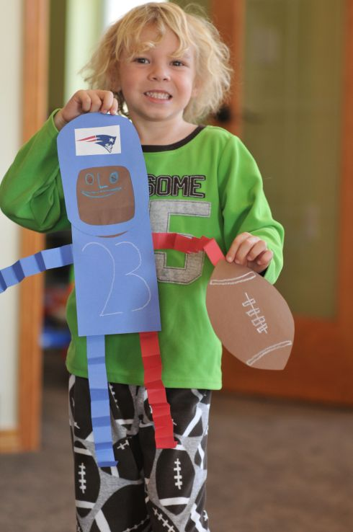

Items you will need:

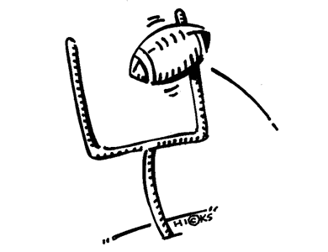\*Red, White, Brown and Blue Construction Paper (or the colors of your favorite team)

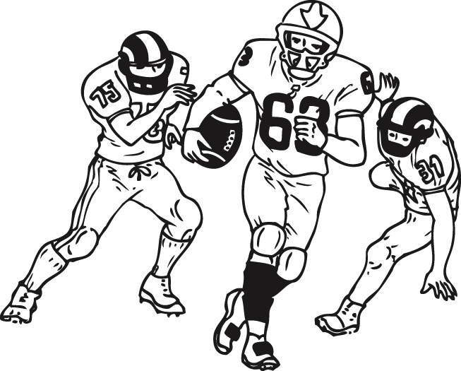\*Skin Colored Construction Paper

\*Crayons or Markers

\*Glue Sticks

\*Scissors

Instructions:

1. Free hand an oval shape for the helmet and cut out a square where the face will go
2. Glue the skin color paper to the back side of the helmet
3. Use the brown paper to draw a football shape then cut it out
4. Cut out a rectangle for the body and some strips of paper for the arms and legs
5. “Fan Fold” the arms and legs
6. Assemble the body however you want and glue it all together
7. Use crayons or markers to draw the faces, jersey numbers and lines on the football