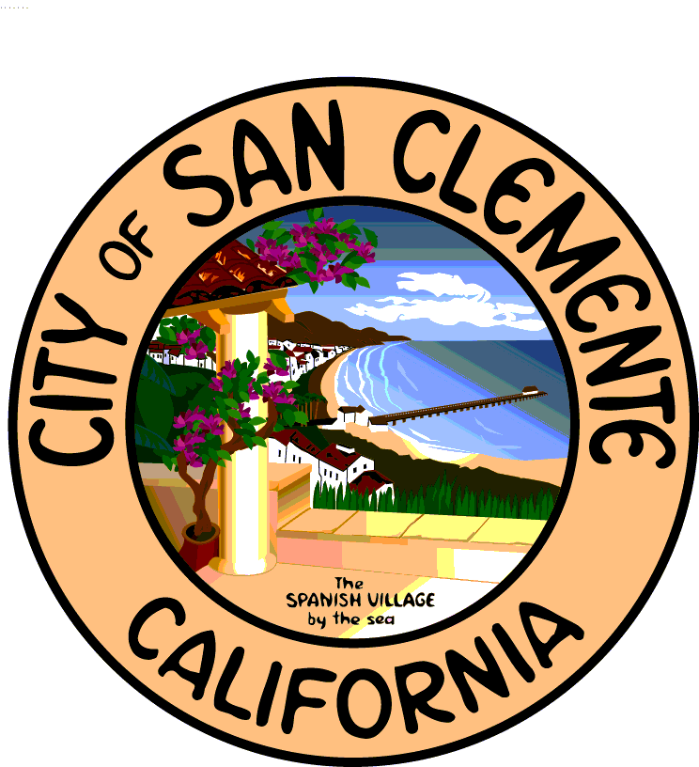City of San Clemente

City Clerk

Joanne M. Baade, City Clerk

Phone: (949) 361-8345 Fax: (949) 361-8309

Baadej@San-Clemente.org

**TO BE PUBLISHED: July 29, 2016**

**1/8 PAGE AD**

**NOTICE OF PUBLIC WORKSHOP**

**NOTICE IS HEREBY GIVEN THAT A PUBLIC**

**WORKSHOP WILL BE HELD BY**

**THE CITY OF SAN CLEMENTE, CALIFORNIA,**

**RELATIVE TO THE FOLLOWING:**

**Cost of Service Study Relating to Water Rates**

The City has engaged Carollo Engineering to conduct a comprehensive Cost-of-Service and Water Rate Study for the City’s Water Utility. As part of that study, City staff and representatives from Carollo Engineering will conduct a public workshop on August 10, 2016 to provide an overview of the City’s Cost-of-Service and Water Rate Study process and timeline, the City’s current water rate structure, and water rate structure methodologies commonly used by other water agencies in California. The purpose of the workshop is to solicit public input. Information relating to this item can be obtained by calling Tom Rendina, Business Services Officer, at (949) 361-8312.

NOTICE IS FURTHER GIVEN that said Public Workshop will be held on August 10, 2016 at 6:00 p.m. in the City Hall Council Chambers, 100 Avenida Presidio, San Clemente, California. All interested persons are invited to attend said workshop, or by written communications to the City to express their opinion regarding the Cost-of-Service and Water Rate Study.

JOANNE BAADE

City Clerk and Ex-Officio

Clerk of the Council